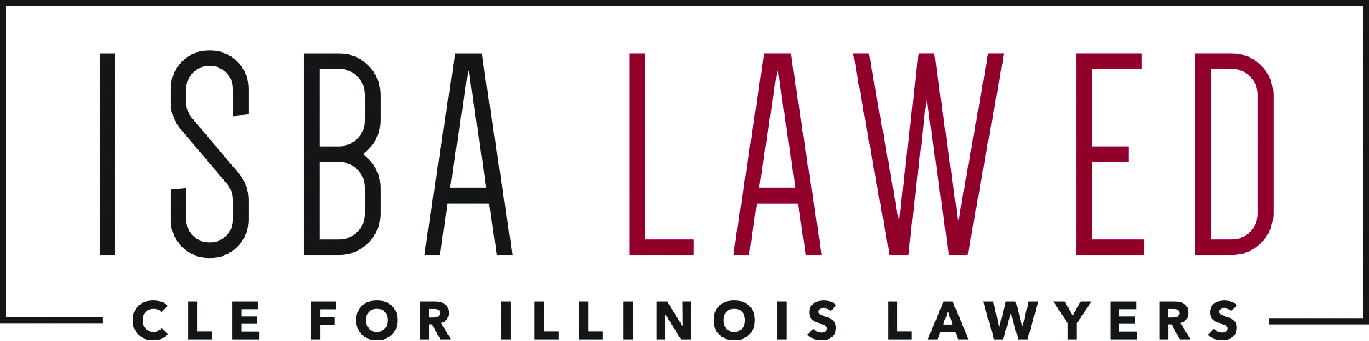

ISBA Section/Committee Request to Extend
Online CLE Program Accreditation Period

Program Title:

Sponsoring Section or Committee:

CLE Coordinator Making the Request:

Expiration Date Listed in ISBA Online CLE Catalog:
(typically two years from original recording date)

New Expiration Date Requested:
(up to two years from current expiration date)

Date Submitted:

Submit this request:
To the ISBA CLE Department, Attn: Tara Sanders
Illinois State Bar Association, 424 South Second Street, Springfield, IL 62701
Fax: (217) 525-0712 / Email: tsanders@isba.org
We will notify you when the extension is completed.

